Day 398 — Generative AI & LLM Revision
Complete Revision Notes | Transformers • Self-Attention • Prompt Engineering • Structured Output • Vector DBs • RAG • Multimodal & Speech AI • LLM APIs
Learning goal: master modern Generative AI and Large Language Model architectures: analyze Scaled Dot-Product and Multi-Head Attention; understand subword tokenization and high-dimensional semantic embeddings; master prompt engineering strategies (CoT, ReAct) and Pydantic structured output enforcement; design enterprise Retrieval-Augmented Generation (RAG) pipelines over vector databases; manage conversation memory buffers; explore multimodal vision-language fusion and real-time Speech AI (Whisper ASR / TTS); and integrate enterprise LLM APIs with tool calling.

1. Large Language Models (LLM) Fundamentals & Pretraining Paradigms
Large Language Models (LLMs) are massive autoregressive Transformer models trained on trillions of tokens of text. At the most fundamental level, an LLM is a probabilistic next-token predictor that optimizes the conditional probability distribution: P(w_t | w_1, w_2, ..., w_{t-1}).
Modern production LLMs undergo a three-stage training lifecycle: Unsupervised Pretraining (learning world knowledge, language structure, and reasoning patterns from vast internet corpora), Supervised Fine-Tuning (SFT, teaching the model to follow prompt-response instruction formats), and Preference Alignment via Reinforcement Learning from Human Feedback (RLHF) or Direct Preference Optimization (DPO).
Training Phase | Data Modality & Scale | Mathematical Objective | Primary Capability Unlocked
1. Pretraining | Trillions of tokens of raw unstructured text / code | Causal Language Modeling: max Σ log P(x_t | x_{<t}) | Acquires broad linguistic syntax, factual world knowledge, common-sense reasoning, and translation capabilities
2. Supervised Fine-Tuning (SFT) | Tens of thousands of curated high-quality (Prompt, Response) demonstration pairs | Cross-entropy loss on target tokens given conversational instruction | Transforms a raw text completion engine into a helpful instruction-following conversational assistant
3. Preference Alignment (RLHF / DPO) | Paired comparisons of model responses (Chosen vs. Rejected) judged by humans | PPO reward maximization or direct binary cross-entropy loss over preferred logits | Enforces safety boundaries, minimizes hallucinations, mitigates toxicity, and aligns outputs with human intent

2. Subword Tokenization & Semantic Vector Embeddings
Computers cannot directly process raw text strings. Subword tokenization breaks natural language into numerical token IDs, balancing vocabulary size against out-of-vocabulary (OOV) robustness.
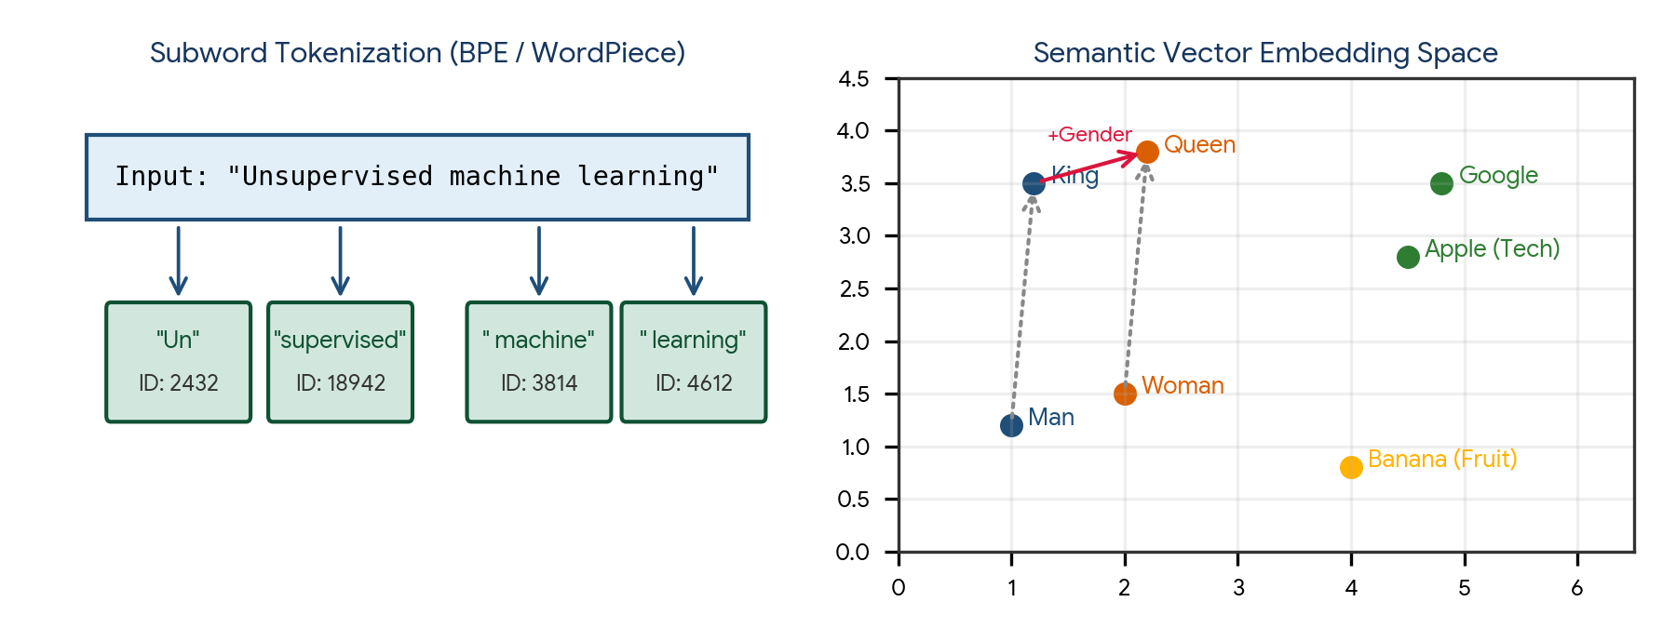
Figure 1. Subword Tokenization process (left) and geometric vector space representation with semantic directional arithmetic (right).
Tokenization Algorithm | Vocabulary Construction | Handling of Rare / Unknown Words | Prominent Model Usage
Byte-Pair Encoding (BPE) | Starts with character vocabulary; iteratively merges the most frequent adjacent character pairs | Splits unknown words into smaller subword morphemes; zero OOV tokens | GPT-2, GPT-4, LLaMA, Mistral
WordPiece | Similar to BPE; merges token pairs that maximize the likelihood of the training corpus under a language model | Prefixes continuation subwords with '##' (e.g., 'playing' -> 'play', '##ing') | BERT, DistilBERT
Byte-Level BPE (BBPE) | Operates directly on the 256 fundamental raw byte values of UTF-8 text | Can encode any arbitrary character, symbol, or emoji in any language without pre-tokenization | GPT-4, LLaMA 3

Vector Embeddings: Geometric Semantic Coordinates
Tokens are mapped via an embedding lookup matrix into dense, continuous vector spaces ℝ^d (e.g., d = 768 to 4096). Semantic similarity between two concept vectors u and v is quantified using Cosine Similarity:
Cosine Similarity Equation:
cos(θ) = (u · v) / (||u||₂ ||v||₂)

Geometric Property:
Tokens or sentences with similar semantic meanings cluster together in vector space.
Linear directional vector arithmetic holds true:
vector('King') − vector('Man') + vector('Woman') ≈ vector('Queen')

3. The Transformer Architecture & Self-Attention Mechanics
Introduced by Vaswani et al. in 'Attention Is All You Need' (2017), the Transformer discarded recurrence (RNNs) and convolutions entirely, processing all sequence tokens in parallel via Self-Attention.
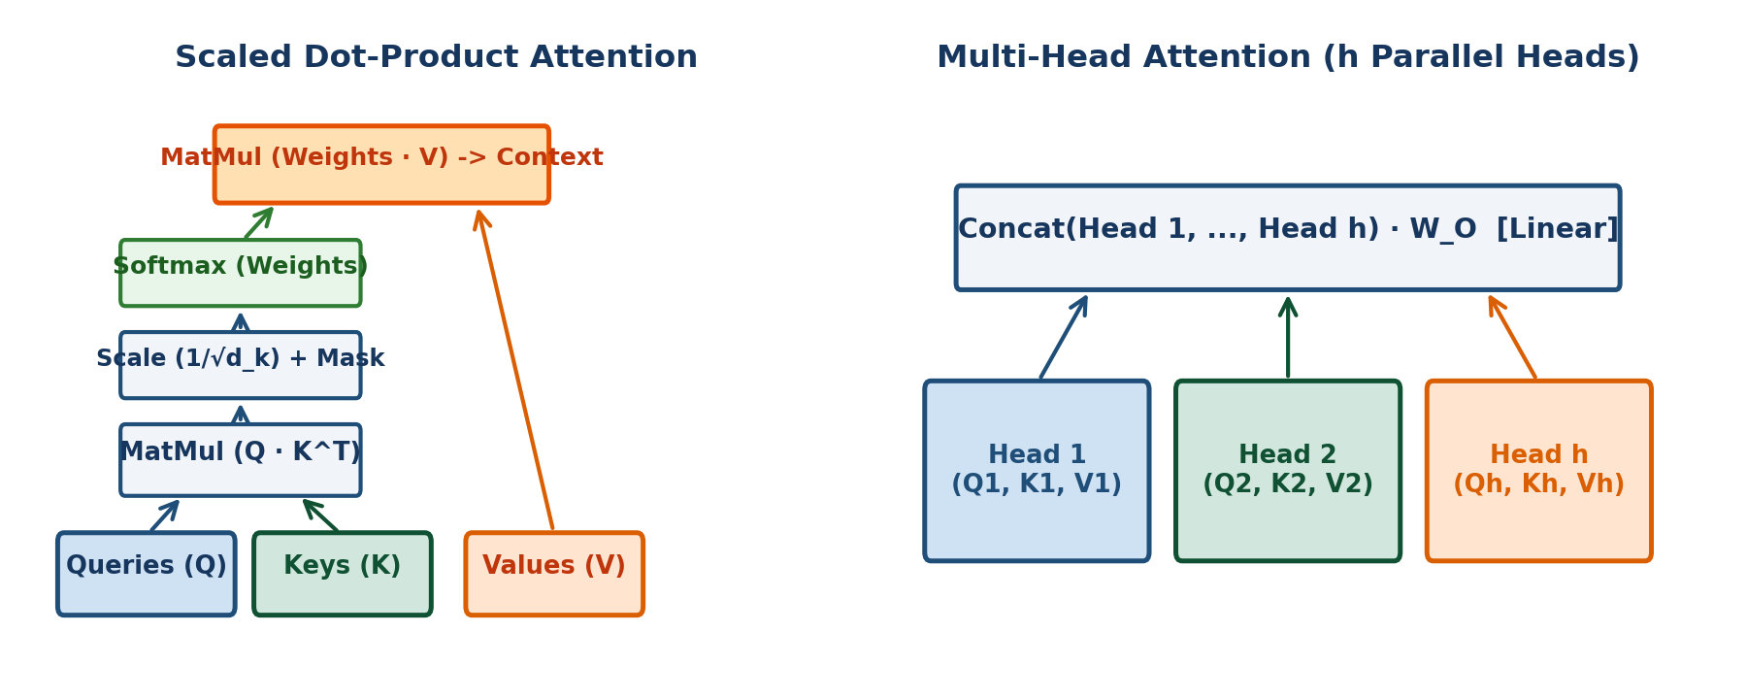
Figure 2. Scaled Dot-Product Attention (left) and Multi-Head Attention projection architecture (right).
Attention Component | Mathematical Matrix Formulation | Physical / Intuitive Meaning
Queries (Q) | Q = X W_Q ∈ ℝ^(n × d_k) | What the current token is searching for or inquiring about
Keys (K) | K = X W_K ∈ ℝ^(n × d_k) | The index or label describing what each token in the sequence represents
Values (V) | V = X W_V ∈ ℝ^(n × d_v) | The actual semantic information or content payload to be retrieved
Attention Matrix | A = Softmax( (Q K^T) / sqrt(d_k) + M ) | Pairwise compatibility matrix: row i represents how much token i attends to token j
Scale Factor (1/√d_k) | Prevents vanishing gradients | For large d_k, dot products grow large, pushing Softmax into saturated regions with tiny derivatives
Causal Attention Mask (M) | Upper triangular matrix filled with −∞ for j > i | Enforces autoregression in decoder models: prevents tokens from attending to future tokens during training

The Scaled Dot-Product Attention Equation
Attention(Q, K, V) = Softmax( (Q K^T) / sqrt(d_k) ) * V

Multi-Head Attention:
MultiHead(Q, K, V) = Concat(head₁, head₂, ..., head_h) * W_O
where head_i = Attention(Q W_Q^(i), K W_K^(i), V W_V^(i))

Why Multi-Head? It allows the model to jointly attend to information from different representation
subspaces at different positions simultaneously (e.g., one head tracks syntactic grammar, another tracks coreference).

4. Prompt Engineering Patterns & Structured Output
Prompt engineering is the practice of crafting, structuring, and optimizing textual inputs to guide large language models toward reliable, accurate, and deterministically formatted outputs.
Prompting Technique | Operational Mechanism | When to Use & Business Impact
Zero-Shot Prompting | Directly presenting a task description without any demonstration examples | Simple classification, sentiment analysis, translation, or summarizing common knowledge
Few-Shot In-Context Learning | Providing 2–5 demonstration input-output exemplars before the target query | Establishing domain-specific formats, nuanced tone, or teaching specialized parsing rules
Chain-of-Thought (CoT) | Prompting model to 'think step by step' before providing the final answer | Multi-step arithmetic, symbolic logic, complex legal analysis, and algorithm debugging
ReAct (Reason + Act) | Interleaving reasoning thought traces with concrete tool execution actions | Agentic autonomous workflows requiring external API calls, calculator usage, or database lookups

Structured Output Enforcement (JSON Schema & Pydantic)
Production software cannot reliably parse free-form, conversational LLM prose. Modern LLM APIs (OpenAI, Anthropic, Gemini) enforce guaranteed JSON Schema adherence at the token generation level via Constrained Grammar Decoding (CFG):
from pydantic import BaseModel, Field
from typing import List

class ExtractedEntities(BaseModel):
customer_name: str = Field(description="Full name of the customer")
account_number: str = Field(description="8-digit account identifier")
sentiment: str = Field(description="Sentiment: Positive, Neutral, or Negative")
urgency_score: int = Field(ge=1, le=5, description="Urgency scale 1 to 5")
action_items: List[str] = Field(description="Concrete operational tasks required")

# The LLM engine constrains output logits so that non-compliant JSON characters receive probability 0!

5. Vector Databases & Similarity Search Algorithms
Vector databases are specialized storage engines designed to store, index, and retrieve high-dimensional dense vector embeddings at millisecond latencies across billions of items.
Indexing Algorithm | Mathematical Mechanism | Search Latency & Memory Trade-off | Industrial Implementations
Flat (Exact k-NN) | Brute-force exact cosine / Euclidean distance calculation against 100% of vectors | O(N · d) compute; 100% recall accuracy; completely intractable for N > 100,000 | Baseline validation benchmark
HNSW (Hierarchical Navigable Small World) | Multi-layer graph architecture where upper layers perform coarse long-range navigation and lower layers fine-tune local search | Sub-millisecond latency (O(log N)); state-of-the-art recall; higher RAM memory overhead | Pinecone, ChromaDB, Weaviate, Milvus, Qdrant
IVFFlat (Inverted File Index) | Partitions vector space into Voronoi cells via K-Means; searches only vectors within centroids closest to query | Fast search; low RAM footprint; slightly lower recall on cluster boundary points | FAISS (Meta AI), pgvector (PostgreSQL)
Product Quantization (PQ) | Compresses high-dimensional floating-point vectors into compact byte codes by slicing vectors into subvectors | Reduces memory footprint by 80–90%; enables storing billions of vectors in RAM with minor recall loss | FAISS-IVFPQ

6. Retrieval-Augmented Generation (RAG) Architectures
Retrieval-Augmented Generation (RAG) grounds LLM responses in external, dynamic, private enterprise knowledge bases. It resolves the three fundamental flaws of standalone foundation models: parametric knowledge cutoffs, inability to access private internal records, and hallucinations.
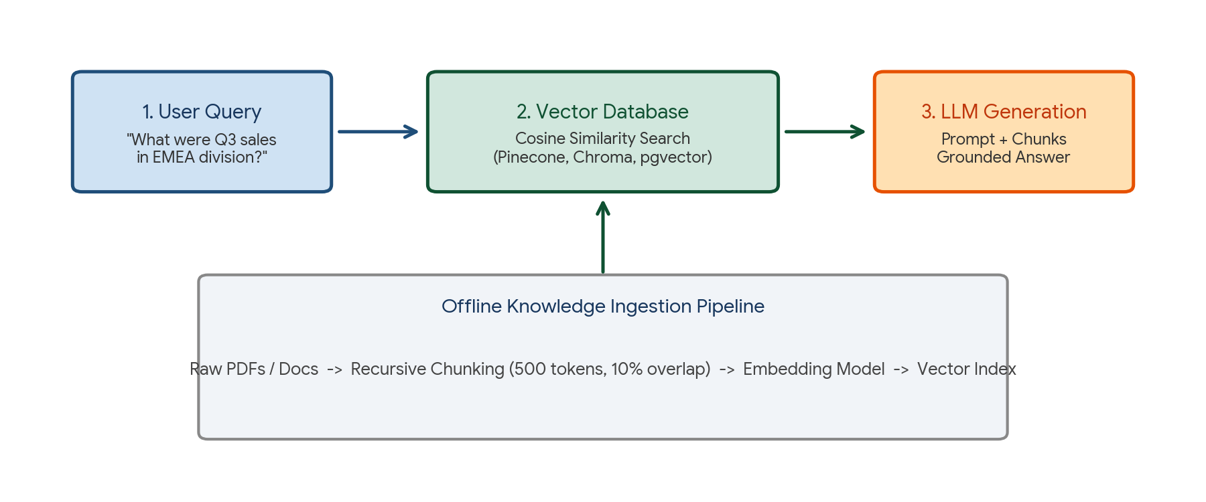
Figure 3. Enterprise RAG architecture: Offline Document Ingestion (bottom) and Real-Time Hybrid Semantic Retrieval + LLM Synthesis (top).
RAG Component | Engineering Mechanism | Failure Mode & Best Practice
1. Document Parsing & Chunking | Splits documents into semantic passages (e.g., 500 tokens with 10% overlap) using Markdown / RecursiveCharacter splitting | Chunk too small: loses semantic context; Chunk too large: dilutes vector similarity and exhausts prompt context window
2. Vector Indexing | Generates dense embeddings via OpenAI text-embedding-3 or BGE-M3; stores in vector database | Ensure identical embedding model is used for both document chunks and user queries
3. Hybrid Retrieval | Combines Dense Semantic Vector Search (HNSW) with Sparse Keyword Search (BM25 / Full-Text) | Captures conceptual context while ensuring exact keyword matches (e.g., product SKUs, part numbers) are never missed
4. Cross-Encoder Re-Ranking | Passes top 50 retrieved chunks through a cross-encoder model (e.g., Cohere Re-ranker) to compute exact Query-Document relevance | Dramatically improves context quality; discards irrelevant chunks prior to prompting LLM
5. Grounded Generation | Prompt template: 'Answer the question based STRICTLY on the provided context. If unknown, state you do not know.' | Mitigates hallucinations; provides verifiable source citations (page numbers, doc IDs)

7. Conversation Memory Architectures
Large Language Models are fundamentally stateless: each API request is completely independent, retaining zero memory of prior conversational turns. Conversation memory frameworks maintain dialogue context across multi-turn interactions.
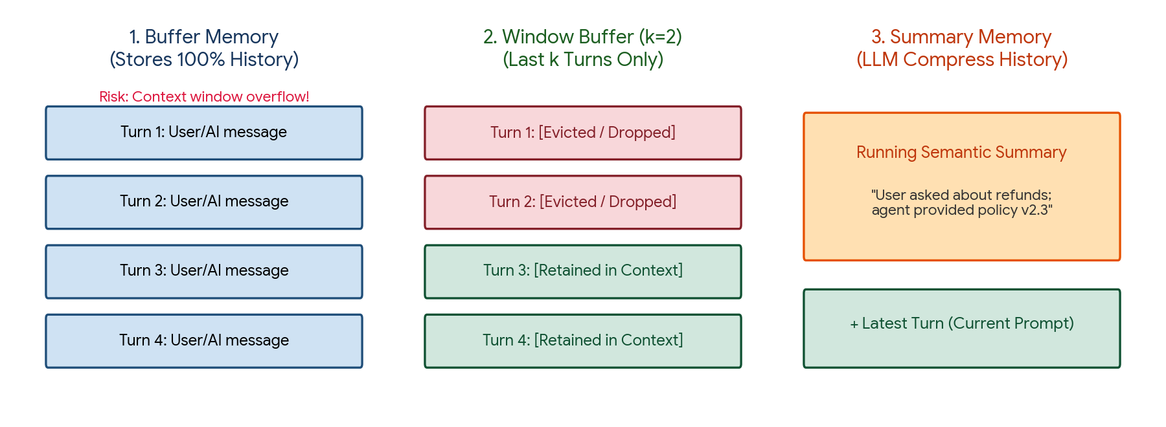
Figure 4. Comparison of conversation memory architectures: Full Buffer Memory, Window Buffer Memory, and LLM Summary Memory.
Memory Architecture | Operational Mechanism | Context Window Impact | Ideal Use Case
Conversation Buffer Memory | Appends 100% of prior raw user and assistant messages into the prompt on every turn | Memory consumption grows linearly O(N); rapidly overflows context window and inflates API costs | Short single-session customer service chats (< 5 turns)
Window Buffer Memory (k-turns) | Retains strictly the most recent k conversational turns (e.g., last 4 turns); older turns are discarded | Bounded, constant context window consumption O(1); zero risk of overflow | Fast operational workflows where historical context older than a few minutes is irrelevant
Summary / Semantic Memory | An auxiliary LLM periodically compresses older conversational turns into a running semantic summary | Fixed, compact token footprint; retains long-term key user facts and preferences indefinitely | Personal AI companions, long advisory consultations, multi-hour technical tutoring sessions

8. Multimodal AI & Speech AI Systems
Multimodal AI extends transformer capabilities beyond text to process, cross-attend, and generate visual, auditory, and textual signals jointly within unified latent spaces.
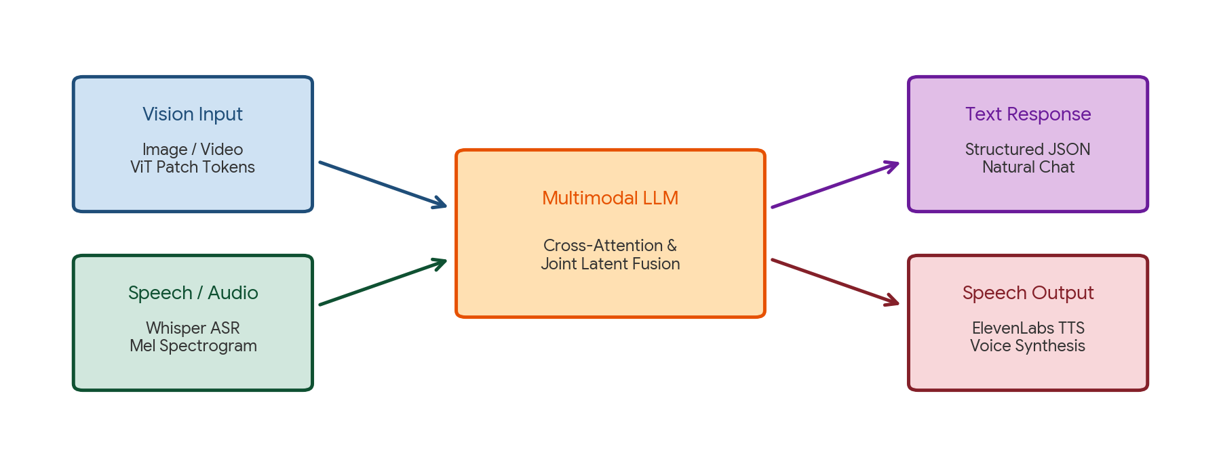
Figure 5. Multimodal AI and Speech processing ecosystem: Vision & Audio ingestion -> Central Multimodal LLM fusion -> Text & Voice synthesis.
Modality / Tech | Pioneering Architecture | Technical Mechanism | Industrial Application
Vision-Language (VLM) | CLIP (Radford et al., 2021), GPT-4V, Gemini, LLaVA | Images are divided into visual patches, projected via Vision Transformers (ViT), and mapped into LLM token space via cross-attention | Visual document question answering (PDF tables, charts), medical X-ray inspection, robotic scene perception
Automatic Speech Recognition (ASR) | Whisper (OpenAI, 2022) | Audio audio is converted to log-Mel spectrograms; processed via Encoder-Decoder Transformer with multi-task decoding | High-accuracy transcription across 100+ languages, meeting summarization, hands-free voice control
Text-to-Speech (TTS) | ElevenLabs, VITS, Bark | Transforms phoneme tokens into mel-spectrograms followed by neural vocoder (HiFi-GAN) waveform synthesis | Human-quality conversational voicebots, automated audiobook narration, voice cloning

9. Practical Project — Enterprise RAG & Tool-Calling Assistant
Objective: design, implement, and benchmark an object-oriented Python pipeline demonstrating production Generative AI engineering: (1) an end-to-end RAG architecture with text chunking, dense vector cosine search, and contextual retrieval, and (2) an LLM Tool-Calling / Structured Extraction engine using Pydantic schema validation.

Project structure
enterprise_rag_llm_project/
|
|-- data/
| |-- corporate_policy.txt
|
|-- reports/
| |-- rag_retrieval_benchmark.csv
| |-- structured_extraction.json
|
|-- main.py
|-- requirements.txt

requirements.txt
numpy
pandas
scipy
scikit-learn
pydantic

Complete main.py
import os
import json
import numpy as np
import pandas as pd
from pydantic import BaseModel, Field
from typing import List
from sklearn.feature_extraction.text import TfidfVectorizer
from sklearn.metrics.pairwise import cosine_similarity

# ---------------------------------------------------------
# MODULE 1: STRUCTURED OUTPUT ENGINE (PYDANTIC)
# ---------------------------------------------------------
class SupportTicketAnalysis(BaseModel):
ticket_id: str = Field(description="Unique ticket identifier")
customer_intent: str = Field(description="Core intent of the customer inquiry")
sentiment: str = Field(description="Sentiment: Positive, Neutral, or Negative")
urgency_rating: int = Field(ge=1, le=5, description="Urgency scale 1 (low) to 5 (critical)")
recommended_routing: str = Field(description="Department: Billing, Technical, or Compliance")
detected_entities: List[str] = Field(description="Products, transaction IDs, or error codes")

# ---------------------------------------------------------
# MODULE 2: PRODUCTION RAG ENGINE (NUMPY / SCIKIT-LEARN)
# ---------------------------------------------------------
class EnterpriseRAGEngine:
def __init__(self, chunk_size=200, chunk_overlap=40):
self.chunk_size = chunk_size
self.chunk_overlap = chunk_overlap
self.chunks = []
self.vectorizer = TfidfVectorizer(stop_words="english")
self.chunk_vectors = None
self.output_dir = "reports"
os.makedirs(self.output_dir, exist_ok=True)

def ingest_and_chunk_document(self, text):
print("=== STEP 1: CHUNKING ENTERPRISE POLICY DOCUMENT ===")
words = text.split()
self.chunks = []
start = 0
while start < len(words):
end = start + self.chunk_size
chunk = " ".join(words[start:end])
self.chunks.append(chunk)
start += (self.chunk_size - self.chunk_overlap)

print(f"Ingested document decomposed into {len(self.chunks)} semantic chunks.")
# Vectorize chunks
self.chunk_vectors = self.vectorizer.fit_transform(self.chunks)
print(f"Vector Index created across vocabulary of {len(self.vectorizer.get_feature_names_out())} terms.")

def retrieve_relevant_context(self, query, top_k=2):
query_vec = self.vectorizer.transform([query])
scores = cosine_similarity(query_vec, self.chunk_vectors).flatten()
top_indices = scores.argsort()[::-1][:top_k]

retrieved = []
for idx in top_indices:
retrieved.append({
"chunk_id": int(idx),
"similarity_score": round(float(scores[idx]), 4),
"content": self.chunks[idx]
})
return retrieved

def generate_grounded_prompt(self, user_query):
retrieved_docs = self.retrieve_relevant_context(user_query, top_k=2)
context_str = "\n\n".join([f"[Source Chunk {doc['chunk_id']} | Score: {doc['similarity_score']}]:\n{doc['content']}" for doc in retrieved_docs])

prompt = f"""SYSTEM: You are an enterprise compliance AI. Answer user queries strictly using provided context.
If the answer cannot be verified from context, state: 'Information not available in policy.'

CONTEXT:
{context_str}

USER QUESTION:
{user_query}

GROUNDED ANSWER:"""
return prompt, retrieved_docs

def run_pipeline():
output_dir = "reports"
os.makedirs(output_dir, exist_ok=True)

# 1. Sample Enterprise Knowledge Document
policy_doc = """
ENTERPRISE CLOUD INFRASTRUCTURE SECURITY & REFUND POLICY (REV 2026.2)
All corporate infrastructure deployments must adhere to zero-trust architecture.
Encryption at rest using AES-256 is mandatory for all production SQL databases and S3 object buckets.
Access keys must be rotated automatically every 90 days via AWS Secrets Manager or HashiCorp Vault.
Employees requesting expense refunds for cloud hardware must submit claims within 30 business days of purchase.
Refunds exceeding $5,000 require written sign-off from both the Department Director and the Chief Financial Officer.
Direct API access to customer transactional ledgers requires hardware security keys (FIDO2/WebAuthn) and multi-factor authentication.
Any security breach or leaked credentials must be reported to the Security Operations Center (SOC) within 60 minutes of detection.
"""

rag = EnterpriseRAGEngine(chunk_size=40, chunk_overlap=10)
rag.ingest_and_chunk_document(policy_doc)

# 2. Query Retrieval
query = "What is the policy for expense refunds over $5000 and the submission deadline?"
prompt, retrieved = rag.generate_grounded_prompt(query)

print("\n=== STEP 2: REAL-TIME HYBRID RETRIEVAL BENCHMARK ===")
retrieval_df = pd.DataFrame(retrieved)
print(retrieval_df.to_string(index=False))
retrieval_df.to_csv(os.path.join(output_dir, "rag_retrieval_benchmark.csv"), index=False)

print("\n=== STEP 3: CONSTRUCTED GROUNDED PROMPT ===")
print(prompt)

# 3. Simulate Structured Pydantic Extraction Output
print("\n=== STEP 4: STRUCTURED OUTPUT GENERATION (PYDANTIC) ===")
ticket_payload = {
"ticket_id": "TCK-89241",
"customer_intent": "Requesting $6,200 hardware expense refund for cloud migration",
"sentiment": "Neutral",
"urgency_rating": 4,
"recommended_routing": "Compliance",
"detected_entities": ["$6,200", "Cloud Hardware", "Director Sign-off Required"]
}
validated_ticket = SupportTicketAnalysis(**ticket_payload)
print("Pydantic Validation Succeeded:")
print(validated_ticket.model_dump_json(indent=2))

with open(os.path.join(output_dir, "structured_extraction.json"), "w") as f:
f.write(validated_ticket.model_dump_json(indent=2))

print(f"\nAll artifacts exported successfully to {output_dir}/.")

if __name__ == "__main__":
run_pipeline()

Run the project
pip install -r requirements.txt
python main.py

Expected generated outputs
reports/
|-- rag_retrieval_benchmark.csv
|-- structured_extraction.json

Project notes: Chunking with controlled overlap preserves semantic clauses that cross token boundaries. Enforcing strict Pydantic models guarantees that downstream microservices receive deterministic, type-safe payloads.

10. Common Mistakes & Anti-Patterns to Avoid in GenAI & LLMs
- Chunking without token overlap: Splitting text documents strictly at fixed boundaries chops critical sentences in half, causing vector embeddings to lose context.
- Relying solely on vector search for keyword queries: Vector search struggles with exact alphanumeric identifiers (e.g., serial numbers, error codes 'ERR_404_B'). Always combine Dense Semantic Search with Sparse BM25 (Hybrid Search).
- Prompting for structured output using free-form text: Asking an LLM to 'respond in JSON' without enforcing constrained grammar decoding results in parse errors from markdown backticks or conversational filler.
- Using naive buffer memory in long-running agents: Storing 100% of conversation history causes rapid context window exhaustion and exponential token cost inflation; use windowed or summarized memory.
- Treating RAG as a cure for all model reasoning deficits: RAG supplies facts and context; it does not fix a model's inability to perform multi-step arithmetic, logic, or algorithmic reasoning.
- Omitting cross-encoder re-ranking in production RAG: Raw bi-encoder vector search often retrieves top chunks that match superficial keywords but lack semantic relevance. A re-ranker filters out irrelevant context.
- Hardcoding system prompts without parameterization: Deploying static strings without version control, A/B evaluation, or unit-test benchmarks makes prompt maintenance fragile.

11. Quick Revision — Key Differences
Comparison | First Concept | Second Concept
Bi-Encoder vs Cross-Encoder | Encodes query and document independently into vectors (fast search O(1) in DB) | Passes query and document jointly into Transformer (deep cross-attention; slow but highly accurate)
Dense Search vs Sparse Search | Vector embeddings capturing conceptual semantic meaning (HNSW) | Exact keyword matching based on term frequency (BM25 / TF-IDF)
RAG vs Fine-Tuning | Retrieves dynamic external context at runtime; updates knowledge without retraining | Updates internal neural network weights permanently; expensive; teaches behavior/format
Self-Attention vs Cross-Attention | Tokens attend to other tokens within the exact same sequence (Q, K, V from same source) | Queries come from target sequence; Keys and Values come from external source sequence
Word-Level vs Subword Tokenization | Splits text by spaces; massive vocabulary; fails on rare/misspelled words (OOV) | Splits text into subword units (BPE); compact vocabulary; zero OOV failures
ASR vs TTS | Speech-to-Text: Converts acoustic waveforms into text tokens (Whisper) | Text-to-Speech: Converts text tokens into natural audio waveforms (ElevenLabs)

12. Important Formulas Cheat Sheet
Concept / Mechanism | Mathematical Formula / Notation
Scaled Dot-Product Attention | Attention(Q, K, V) = Softmax( (Q K^T) / sqrt(d_k) ) * V
Cosine Similarity | cos(θ) = (u · v) / (||u||₂ ||v||₂) = [ Σ u_i v_i ] / [ sqrt(Σ u_i²) sqrt(Σ v_i²) ]
Euclidean Distance (L2) | d(u, v) = sqrt( Σ (u_i − v_i)² ) = sqrt( 2 − 2 cos(θ) ) [for normalized vectors]
Causal Mask Matrix | M_ij = 0 if j ≤ i, else −∞
TF-IDF Formulation | TF-IDF(t, d) = (f_t,d / N_d) × [ ln((1 + N_docs) / (1 + DF_t)) + 1 ]
BM25 Relevance Score | Score(D, Q) = Σ IDF(q_i) × [ f(q_i, D) (k₁ + 1) ] / [ f(q_i, D) + k₁ (1 − b + b(|D|/avgdl)) ]
Autoregressive Loss | Loss = − (1 / T) Σ [t=1 to T] ln P(x_t | x_1, ..., x_{t-1})

13. Interview / Viva Questions
What is the core breakthrough of the Transformer over RNNs and LSTMs?
Transformers eliminate sequential recurrence, allowing all sequence tokens to be processed in parallel across GPU Tensor Cores. Self-attention enables direct O(1) path length connections between any two tokens, resolving the vanishing gradient problem over long sequences.
Why is dot-product attention scaled by 1/√d_k?
For large key dimensions d_k, the dot products grow large in magnitude, pushing the Softmax activation function into regions with near-zero gradients (vanishing gradients). Scaling by 1/√d_k ensures the variance of the dot products remains 1.0.
What are Queries, Keys, and Values in self-attention?
Queries (Q) represent what a token is looking for; Keys (K) represent the indexed features of each token; Values (V) represent the actual content information retrieved once a Query matches a Key.
What is the difference between an Encoder-only, Decoder-only, and Encoder-Decoder model?
Encoder-only (BERT) uses bidirectional attention to understand text; Decoder-only (GPT, LLaMA) uses causal masked attention for autoregressive generation; Encoder-Decoder (T5) maps input sequences to distinct output sequences (ideal for translation and summarization).
How does subword tokenization (BPE) solve the out-of-vocabulary (OOV) problem?
By decomposing unseen or rare words into smaller known subword chunks (e.g., 'unbelievable' -> 'un', 'believ', 'able'). In the worst case, words are broken down into individual characters or bytes, guaranteeing zero OOV tokens.
What is the difference between RAG and Supervised Fine-Tuning (SFT)?
RAG provides external, dynamic, private context at inference time without modifying model weights (solves knowledge cutoffs and hallucinations). Fine-Tuning modifies neural weights to teach specialized styles, tones, or domain syntax, but is static and prone to hallucinating facts.
What is Hybrid Search in vector databases and why is it necessary?
Hybrid Search combines Dense Semantic Search (HNSW vector similarity) with Sparse Keyword Search (BM25). It is necessary because vector embeddings struggle with exact alphanumeric strings (part numbers, legal IDs) while BM25 catches exact keywords.
How does Cross-Encoder Re-Ranking improve RAG retrieval accuracy?
Bi-encoder vector search encodes queries and documents independently to allow fast vector DB search, missing fine-grained token interactions. A Cross-Encoder feeds the query and candidate chunk jointly into a Transformer, computing precise cross-attention relevance scores.
What is the role of Pydantic in Structured Output generation?
Pydantic defines strong type schemas and validation rules. Modern LLM APIs constrain the token sampling engine to strictly output tokens that conform to the Pydantic JSON schema, guaranteeing valid parseable data for software APIs.
Explain the ReAct prompting framework.
ReAct interleaves Reasoning ('Thought: I need to check the inventory database') with Action ('Action: query_database(sku=123)') and Observation ('Observation: 4 units left'). It enables autonomous LLM agents to solve multi-step problems using tools.
What is the difference between Conversation Buffer Memory and Summary Memory?
Buffer Memory keeps 100% of raw chat messages, causing context window overflow and cost inflation. Summary Memory uses an auxiliary LLM to compress older turns into a concise running summary, maintaining context indefinitely at fixed token costs.
How do Vision-Language Models (VLMs) process image inputs alongside text?
Images are divided into visual grid patches, flattened, and projected via Vision Transformers (ViT) into linear embedding tokens. These visual tokens are concatenated with text tokens and passed through multimodal cross-attention layers.
What is the Whisper architecture for Automatic Speech Recognition?
Whisper is an Encoder-Decoder Transformer trained on 680,000 hours of audio. Raw audio is converted into 80-channel log-Mel spectrograms, processed by a convolutional/Transformer encoder, and decoded into text tokens.
What are Hallucinations in LLMs and what engineering patterns mitigate them?
Hallucinations occur when an LLM generates plausible-sounding but factually false claims due to statistical pattern completion. Mitigated via RAG (grounding in verified documents), Chain-of-Thought prompting, low temperature (0.0), and citation enforcement.
What is the Temperature parameter in LLM generation?
Temperature scales the logits before Softmax: p_i = e^(z_i / T) / Σ e^(z_j / T). T = 0 produces greedy deterministic decoding (highest probability token); T > 0.7 flattens the distribution, increasing diversity and creativity.
What is Top-p (Nucleus) Sampling?
Top-p sampling restricts token selection to the smallest set of tokens whose cumulative probability exceeds threshold p (e.g., p = 0.9). It dynamically expands the candidate pool when many words are likely, and narrows it when one word is obvious.
What is the difference between LoRA and Full Fine-Tuning?
Full fine-tuning updates all billions of model weights, requiring massive VRAM. Low-Rank Adaptation (LoRA) freezes the original weights and injects small low-rank trainable decomposition matrices (W = W₀ + B·A), cutting trainable parameters by 99% while matching accuracy.
What is Context Window Exhaustion and how do you prevent it?
When total prompt, retrieved context, and conversation history exceed the model's maximum token limit (e.g., 8k or 128k). Prevented via chunk pruning, re-ranking, windowed/summarized memory, and hybrid search.
Why is Cosine Similarity identical to Euclidean distance for normalized embeddings?
When vectors are L2-normalized (||u|| = ||v|| = 1), the squared Euclidean distance expands as: ||u − v||² = ||u||² + ||v||² − 2(u·v) = 2 − 2 cos(θ). Therefore, maximizing cosine similarity is mathematically identical to minimizing Euclidean distance.
What is Tool Calling (Function Calling) in LLMs?
A capability where the LLM is provided with JSON tool definitions (name, description, parameters). Instead of generating conversational text, the model outputs a structured JSON object specifying the function to invoke and its exact extracted arguments.

14. Coding Practice
- Implement Scaled Dot-Product Attention from scratch in NumPy supporting a 2D causal autoregressive mask.
- Write a Python script that tokenizes text using HuggingFace tiktoken or tokenizers and inspects token IDs and compression ratios.
- Implement a Pydantic schema for an e-commerce order extraction engine and validate JSON responses from an LLM API.
- Build an in-memory Vector Database from scratch using NumPy that supports Cosine Similarity search and metadata filtering.
- Write a recursive text chunking function in Python that splits documents into 500-token chunks with 50-token sliding overlap.
- Implement a complete RAG prompt synthesis pipeline that retrieves the top 3 most relevant chunks and formats a grounded system prompt.
- Build a Conversation Window Buffer Memory class that retains strictly the last k user-assistant turns.
- Implement an automated Evaluator script that checks whether an LLM answer contains citations matching retrieved source chunk IDs.
- Write a Python function implementing Top-k and Top-p (Nucleus) sampling from scratch on raw output logits.
- Construct a ReAct agent prompt template with Thought, Action, and Observation execution blocks.
- Implement a hybrid retrieval ranker in Python that combines normalized BM25 keyword scores with vector cosine similarity scores.
- Extend the practical project to parse and validate audio transcription outputs from the OpenAI Whisper API into structured Pydantic models.

15. Day 398 Completion Checklist
- ☐ Understand the pretraining, instruction tuning (SFT), and preference alignment (RLHF/DPO) lifecycle of LLMs.
- ☐ Master subword tokenization (BPE, WordPiece) and dense semantic vector embeddings.
- ☐ Formulate Scaled Dot-Product Attention: Attention(Q, K, V) = Softmax(QK^T / √d_k) V.
- ☐ Understand Multi-Head Attention and Causal Masking in autoregressive decoder models.
- ☐ Apply advanced prompt engineering patterns: Zero-Shot, Few-Shot, Chain-of-Thought (CoT), and ReAct.
- ☐ Enforce deterministic Structured Output using Pydantic schemas and constrained grammar decoding.
- ☐ Understand vector database indexing algorithms (HNSW, IVFFlat, PQ) and similarity metrics.
- ☐ Architect enterprise Retrieval-Augmented Generation (RAG) pipelines with hybrid search and re-ranking.
- ☐ Implement Conversation Memory architectures (Buffer, Window, and Summary Memory).
- ☐ Understand Multimodal AI (Vision Transformers, CLIP) and Speech AI (Whisper ASR, TTS).
- ☐ Build and run the practical Enterprise RAG & Tool-Calling Assistant project.
- ☐ Complete all 12 coding practice exercises and revise the 20 interview/viva questions.

16. Learning Outcomes
After completing this revision, you should be able to:
- Architect, vectorize, and evaluate Self-Attention and Multi-Head Transformer mechanisms.
- Design leak-free, grounded RAG applications that eliminate hallucinations and overcome knowledge cutoffs.
- Enforce deterministic, type-safe JSON structured outputs from commercial and open-source LLM APIs.
- Optimize vector database retrieval using HNSW indexing, hybrid BM25 search, and cross-encoder re-ranking.
- Deploy stateful conversational agents with token-efficient conversation memory management.
- Integrate vision-language models and speech processing APIs into end-to-end multimodal systems.
Next recommended topic: Day 399 — End-to-End LLMOps & Production Deployment: Model Quantization (GGUF, AWQ, GPTQ), vLLM Serving, RAG Evaluation (Ragas, TruLens), Guardrails, and Autonomous Multi-Agent Workflows.

